
Gnome Street Gnome
Raspberry Pi

Headless
We are running our Pi without a screen and keyboard. To do this requires the device to be already setup to access the Wifi.

Bonjour
This software is installed on our Windows machines so that we can access the Pi by it’s name e.g. “RaspberryPi.Local” rather than needing to know it’s number. Note that if you’ve instaled Itunes you will already have this installed.
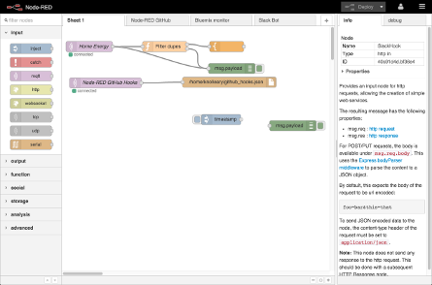
Node-Red
This software allows us to wire together inputs and outputs in flows. We can access this via a web browser on the laptop.

Reference
https://www.raspberrypi.org/documentation/configuration/wireless/
https://support.apple.com/downloads/Bonjour_for_Windows
http://www.howtogeek.com/167190/how-and-why-to-assign-the-.local-domain-to-your-raspberry-pi/
http://nodered.org/

